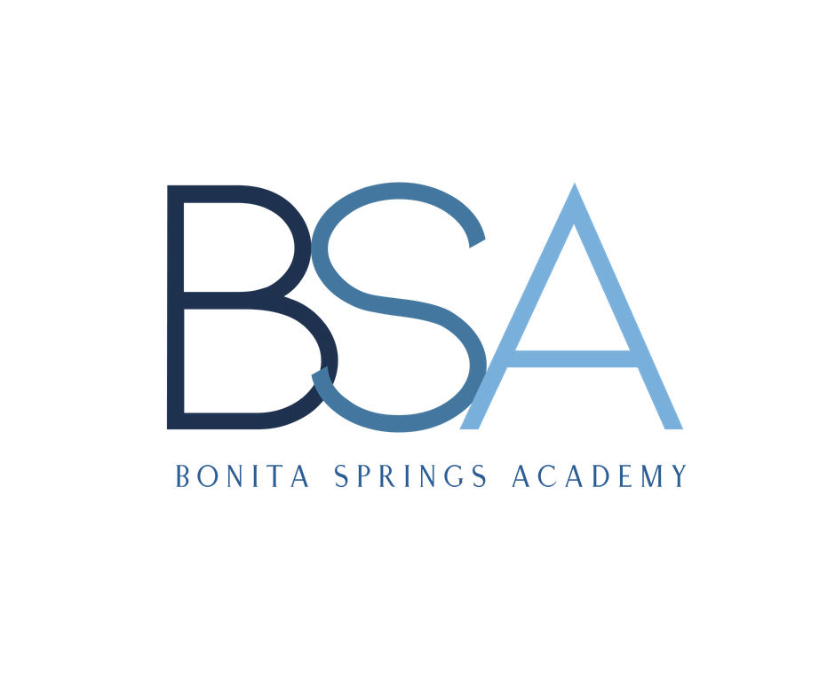 STUDENT APPLICATION

Student's Full Name: ________________________________ Date of Enrollment: __________
Date of Birth: ___ /___ /___ Age: _____ Sex: Male__ Female__
Is your child potty trained? Yes__ No__

FATHER/GUARDIAN MOTHER/GUARDIAN
Name ______________________________________ Name __________________________________________
Address _____________________________________ Address ________________________________________
City __________________ State _____ Zip ________ City ___________________ State _____ Zip __________
Home Phone # ______________________________ Home Phone # _________________________________
Cell Phone # ________________________________ Cell Phone # ___________________________________
Occupation _________________________________ Occupation ____________________________________
Place of Employment_________________________ Place of Employment ____________________________
Work Phone # _______________________________ Work Phone #___________________________________
Email ________________________________________ Email ___________________________________________

Child(ren) Lives With: _____________________________________________________________________

STEP FATHER STEP MOTHER
Name ______________________________________ Name __________________________________________
Address ____________________________________ Address ________________________________________
City __________________ State _____ Zip _______ City __________________ State _____ Zip ___________
Home Phone # _____________________________ Home Phone # _________________________________
Cell Phone # ________________________________ Cell Phone # ___________________________________
Occupation ________________________________ Occupation ____________________________________
Place of Employment_________________________ Place of Employment ___________________________
Work Phone # _______________________________ Work Phone #___________________________________
Email ________________________________________ Email ___________________________________________

Emergency Contacts
Child(ren) will be released only to the custodial parent(s) or legal guardian(s) and the persons listed below.
The following people will also be contacted and are authorized to remove the child from the facility in case
Of Illness, accident or emergency, if for any reason, the custodial parent(s) or legal guardian(s) cannot be reached:

Name ________________________________ Relationship ___________________ Phone #____________________
Name ________________________________ Relationship ___________________ Phone #____________________

Brother’s and Sister's Names and Ages
Name_____________________________ Age ___ Name_____________________________ Age ___
Name_____________________________ Age ___ Name_____________________________ Age ___

Has your child ever attended a daycare or preschool? No__ Yes__ If yes, please provide the
name and phone number of the previous school(s) ____________________________________________________________________________________________

Parental Authorization and Agreement

_________________________________ Date of Birth ___ / ___ /___
(Child's Name)

FINANCIAL AGREEMENT

I understand that tuition payments are based on a weekly payment. I understand that tuition payments

that are not honored by the bank will incur a $25.00 late fee. All payments must be current. Any payment

over 10 days old will result in the removal of your child from the program until all payments, including late

fees, are paid in full. All registration fees and curriculum/activity fees are non-refundable. Attendance

does not change the fee.

I understand that if my child is picked up after 6:00 p.m., I will be charged an additional $5.00 fee for each minute per child, thereafter. (Late payments are to be made directly to Bonita Springs Academy by cash.)

Initials of Parent _____________

PHOTO RELEASE

I give my permission for my child's photograph or video image to be taken while he/she is in the care of
Bonita Springs Academy personnel. Such images may be posted in classrooms or other appropriate areas within the facility, used in Bonita Springs Academy presentations or promotional materials, on Facebook, Instagram or other “controlled” social media, or used in a school annual yearbook. I understand that I may terminate this permission at any time in the future.

Initials of Parent _____________

AUTHORIZATION FOR OBSERVATION AND DEVELOPMENTAL SCREENING

I give my permission for my child to be observed and receive developmental screening which may include vision, hearing, speech, language, motor and developmental skills. I understand that these screenings are to help the teacher plan appropriate activities for my child. I also understand that following these screening the results will be shared with me through a conference.

Initials of Parent _____________

PARENTAL PLEDGE AND SUPPORT

I have received the Bonita Springs Academy policies/procedures handbook and agree to read it in its entirety, and to adhere to the policies as stated.

I have read the Bonita Springs Academy student health policy and agree to adhere and follow the practices and policies as stated.

I have read the Bonita Springs Academy discipline policy and agree to adhere, follow and support the practices and policies as stated.

I have read, consent to, and support all of the above authorizations, pledges and agreements as stated and required by Bonita Springs Academy.

____________________________________________________________ Date: ___ /___ /____
Parent/Guardian Signature

Emergency Treatment and Transportation

______________________________Date of Birth ___ / ___ /___
(Child's Name)

Please check and/or list any medical condition your child may have:

__ Allergies __Asthma __Diabetes __ Heart Condition __Seizures __ Other: _______________________________________________________________________________________

Allergies: _______________________________________________________________________________

________________________________________________________________________________________
If allergic, what are signs/symptoms of allergic reaction? ________________________________________________________________________________________
Other Health Condition(s)/Concerns/Medications: ________________________________________________________________________________________

________________________________________________________________________________________

Authorization for Medication
Disbursement of medication sent in from home is as follows: (1) All medication dispensed at Bonita Springs Academy requires a written authorization by the student’s primary doctor; this includes over-the-counter medication (2) Completion of an Over-the-Counter Medication Authorization Form (3) Medication in the ORIGINAL container - Prescription meds in the original pharmacy labeled container (4) All meds must be delivered by the parent(s) to the classroom teacher. Medications should never be in the possession of the student, including backpack or lunch box.

Authorization for Emergency Medical Care
I understand that it is my responsibility to see that my child has regular medical examinations as required for attendance at Bonita Springs Academy; and that my child's immunizations are kept current as required by the State of Florida. In case of emergency, I/we authorize any representative of Bonita Springs Academy to present the above stated minor to receive any emergency care my child may need.
I give permission for Bonita Springs Academy to call my student's physician and/or dentist, as listed on Application for Enrollment, in the event of an emergency.

Preferred Hospital: ______________________________________________________________________
Doctor: ___________________ Address _____________________________ Phone ________________
Dentist: ___________________ Address _____________________________ Phone ________________

Mother/Legal Guardian’s Printed Name Mother/Legal Guardian’s Signature Date
______________________________________ __________________________________ _________

Father/Legal Guardian’s Printed Name Father/Legal Guardian’s Signature Date

______________________________________ __________________________________ _________

Authorized Student Pick-Up and Release
______________________________Date of Birth ___ / ___ /___
(Child's Name)

Bonita Springs Academy use the following criteria to assure each student is picked up or removed from the Academy by authorized persons only:

1. No child will be released to any person whose name does not appear on this application or has been approved and added by using the authorized addition form.

2. Before any person can remove a child, proper I.D., such as a current Driver's License, must be shown.

3. If there is ever any question as to the identification of any person attempting to remove a child from the Academy, the legal parent or guardian will be notified immediately.

4. The legal parent or guardian must give advanced written authorization before any person not appearing on our Authorized Pick-Up List will be allowed to remove a child from the Academy.

5. In the event of an emergency, the legal parent or guardian may give above stated permission verbally, but only if given directly to the Administrator or authorized office personnel. This new pick-up person will not be added on the permanent list until they are officially added by use of appropriate form.

For your child's protection, THEY WILL NOT be released to an unauthorized person. Approved picture identification (driver's license) will be required.

Bonita Springs Academy defines a legal parent or legal guardian to be person(s) who enrolled the child and whose signature is found on the enrollment form. An official birth certificate proving he/she is the legal parent or guardian is also required. In the case where a divorce or legal separation has occurred or is in process, legal court documentation must be presented as proof that he/she has been awarded temporary or permanent custody of the child in question. We will not hesitate to call 911 immediately if any disruptions or disputes develop on school property. The safety of the minor child in our custody will always take top priority in any situation. This also applies to those allowed to pick up the child from the Academy. ONLY official court documents, whose authenticity has been verified, will supersede any other documents received or placed on file.

I hereby authorize all the above listed names on this application as active and approved people to pick up
my child from Bonita Springs Academy. In any event that the contacts change, I will bring in the proper documentation for my child’s file, so it can be changed.

__________________________________________ _________________________________________ _____________
Mother or Legal Guardian’s Printed Name Mother or Legal Guardian’s Signature Date

__________________________________________ _________________________________________ ____________
Father or Legal Guardian’s Printed Name Father or Legal Guardian’s Signature Date

Discipline Policy & Record Hold
______________________________Date of Birth ___ / ___ /___
(Child's Name)
We encourage positive redirection. Positive discipline teaches children where limits are set, how to maintain control of their bodies, and how to problem solve in the event of the conflict.
We encourage children to empathize with one another’s feelings and see the results of their actions. We discourage inappropriate behavior. We use “Time Out” as our last resort. Any child that is put in time out is always supervised by a teacher and shall remain in time out only 1 minute per age of the child. When time out is over, it is explained to the child why time out occurred and what correct behavior is expected. No child is subjected to corporal punishment or physical discipline at any time. Discipline shall never be related to food, rest, or toileting.
We will make every effort to work with parents of children having difficulties in child care. Behavior of children which disrupts normal classroom group activities on a frequent or extended basis may indicate physical or emotional problems requiring the attention of a professional specialist. The teacher and/or Director, with parental consent, will take the necessary steps to refer the child to the Public Health Nurse, a Mental Health Consultant, or other appropriate places for a professional evaluation.
Children displaying chronic disruptive behavior which is upsetting to the physical or emotional well being of another child may require the following actions: (1) Parents of the child will be called in for a conference. We will discuss the issues and identify some possible solutions. A plan of action will be developed and agreed upon by the parents, staff, and a health/behavioral specialist. (2) If the plan of action is not working, the parents will be called in for another meeting. We will discuss what is not working and develop another action plan. (3) If no progress has been made towards solving the problematic behavior, the child may be suspended from care. Suspension can range from, for the day to a week.
The use of physical force as a discipline measure is prohibited. This includes spanking, slapping, pinching, shaking, biting, pulling hair or arms, jerking, etc.
By signing below, you verify that you have read the above policy and agree with the terms.

__________________________________________ _________________________________________ _____________
Parent/Legal Guardian’s Printed Name Parent/Legal Guardian’s Signature Date

Permission to Hold Records:

I give permission to Bonita Springs Academy to hold and have access to my child’s records, health and immunizations, academic and behavioral information/records.

__________________________________________ _________________________________________ _____________
Parent/Legal Guardian’s Printed Name Parent/Legal Guardian’s Signature Date

Release and Notifications
______________________________Date of Birth ___ / ___ /___
(Child's Name)

Permission for Food-Related Activities and Special Occasions

Classrooms occasionally use food-related items to teach, play and celebrate, Holiday parties
and Birthdays are also celebrated at the Academy. In order for your child(ren) to participate in
any activity, occasion or party you will need to give permission. Please list all food allergies that
your child has below.

_______My child DOES NOT have a food allergy or dietary restriction. My child may participate in activities.

_______My child DOES have a food allergy/dietary restriction My child may participate in all
activities, but may NOT eat or handle the following items (listed below)
______________________________________________________________________________________________

_______My child may NOT participate in any food activity.

I understand that it is my responsibility to update this form in the event that my decision for permission changes. I agree that this form will remain in effect during the term of my child’s enrollment.

__________________________________________ _________________________________________ _____________
Parent/Legal Guardian’s Printed Name Parent/Legal Guardian’s Signature Date

Permission to Watch Movies

Occasionally, classrooms will watch appropriate aged movies. Disney movies are rated PG which
suggests movies be watched with guidance. All movies, cartoons etc. are now given a rating of PG.
In order for your child to participate, you will need to sign below.

I give permission for my child to watch PG movies (Disney)at Bonita Springs Academy, I realize that these movies are age appropriate, with no profanity, or questionable content.

__________________________________________ _________________________________________ _____________
Parent/Legal Guardian’s Printed Name Parent/Legal Guardian’s Signature Date

